Social Studies Grade 4 Training Test
Question Number | Answer | DE Content Benchmark
1 | A | H.1.4-5a
2 | B | H.2.4-5a
3 | 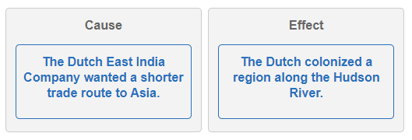 | H.1.4-5a
4 | 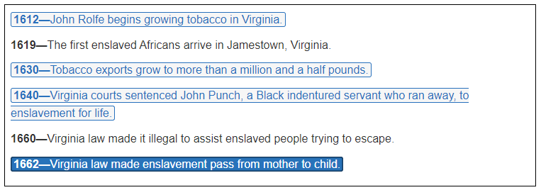 | H.2.4-5b
5 | A | H.1.4-5a
6 | C | H.2.4-5b
7 | 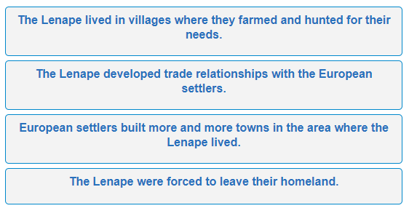 | H.1.4-5a
8 | 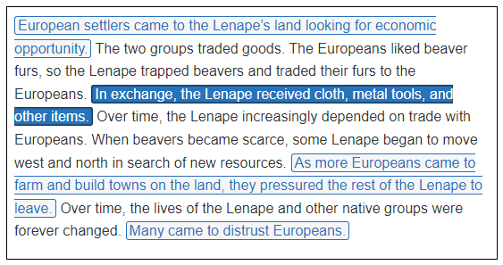 | H.1.4-5a
9 | A | H.3.4-5a
10 | A | H.2.4-5a
11 | D | H.2.4-5b
12 | A | H.2.4-5a
13 | 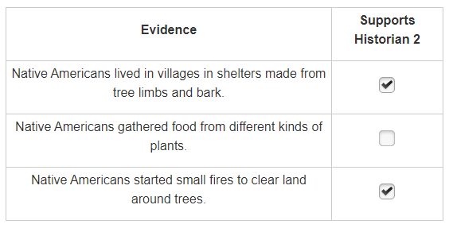 | H.3.4-5a
14 | 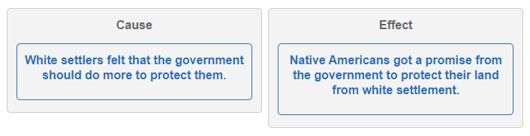 | H.1.4-5a
15 | A | H.2.4-5a

